**Weekly Assignment (13/03/2022)**

**Assignment 1: Create a DB for your college with following parameters**

1. Create a table for students with name, age, mobile no, registration no., year of batch as columns.

2. Create a table for teachers with name, domain, department as column

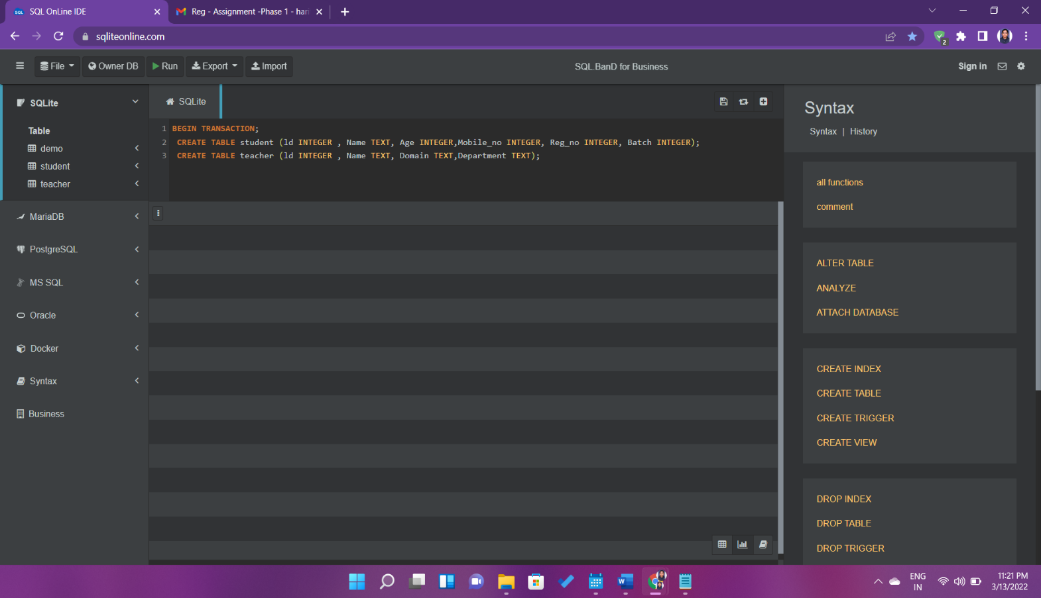

**QUERY**

BEGIN TRANSACTION;

CREATE TABLE student (ld INTEGER , Name TEXT, Age INTEGER, Mobile_no INTEGER, Reg_no INTEGER, Batch INTEGER);

CREATE TABLE teacher (ld INTEGER , Name TEXT, Domain Text ,Department TEXT);

3. Write a query to insert 10 students data and 10 teachers data in the respective table

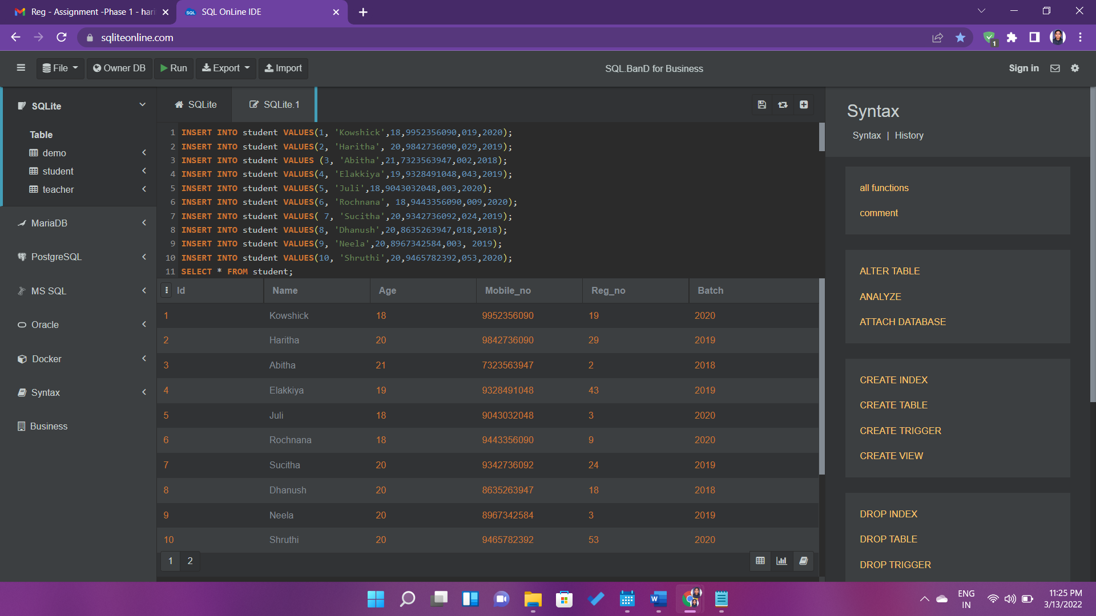

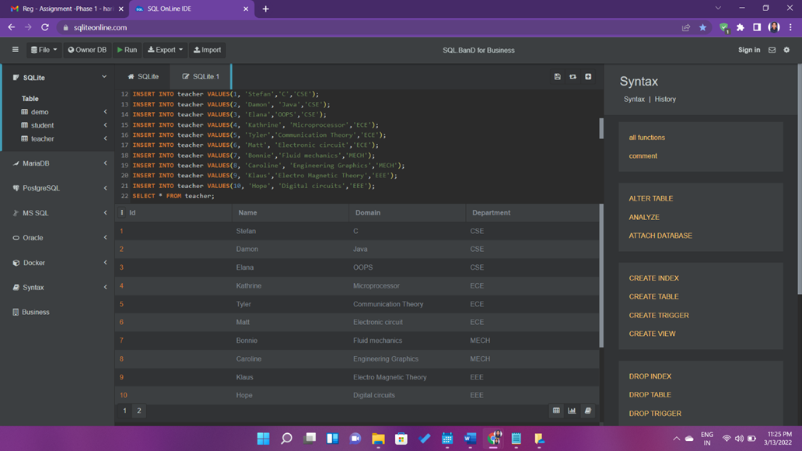

**QUERY**

INSERT INTO student VALUES (1, 'Kowshick',18,9952356090,019,2020);

INSERT INTO student VALUES (2, 'Haritha', 20,9842736090,029,2019);

INSERT INTO student VALUES (3, 'Abitha',21,7323563947,002,2018);

INSERT INTO student VALUES (4, 'Elakkiya',19,9328491048,043,2019);

INSERT INTO student VALUES (5, 'Juli',18,9043032048,003,2020);

INSERT INTO student VALUES (6, 'Rochnana', 18,9443356090,009,2020);

INSERT INTO student VALUES ( 7, 'Sucitha',20,9342736092,024,2019);

INSERT INTO student VALUES (8, 'Dhanush',20,8635263947,018,2018);

INSERT INTO student VALUES (9, 'Neela',20,8967342584,003, 2019);

INSERT INTO student VALUES (10, 'Shruthi',20,9465782392,053,2020);

SELECT * FROM student;

INSERT INTO teacher VALUES (1, 'Stefan','C','CSE');

INSERT INTO teacher VALUES (2, 'Damon', 'Java','CSE');

INSERT INTO teacher VALUES (3, 'Elana','OOPS','CSE');

INSERT INTO teacher VALUES (4, 'Kathrine', 'Microprocessor','ECE');

INSERT INTO teacher VALUES (5, 'Tyler','Communication Theory','ECE');

INSERT INTO teacher VALUES (6, 'Matt', 'Electronic circuit','ECE');

INSERT INTO teacher VALUES (7, 'Bonnie','Fluid mechanics','MECH');

INSERT INTO teacher VALUES (8, 'Caroline', 'Engineering Graphics','MECH');

INSERT INTO teacher VALUES ( 9, 'Klaus','Electro Magnetic Theory','EEE');

INSERT INTO teacher VALUES (10, 'Hope', 'Digital circuits','EEE');

SELECT * FROM teacher;

4. Write a query to fetch all the students from 2020 batch

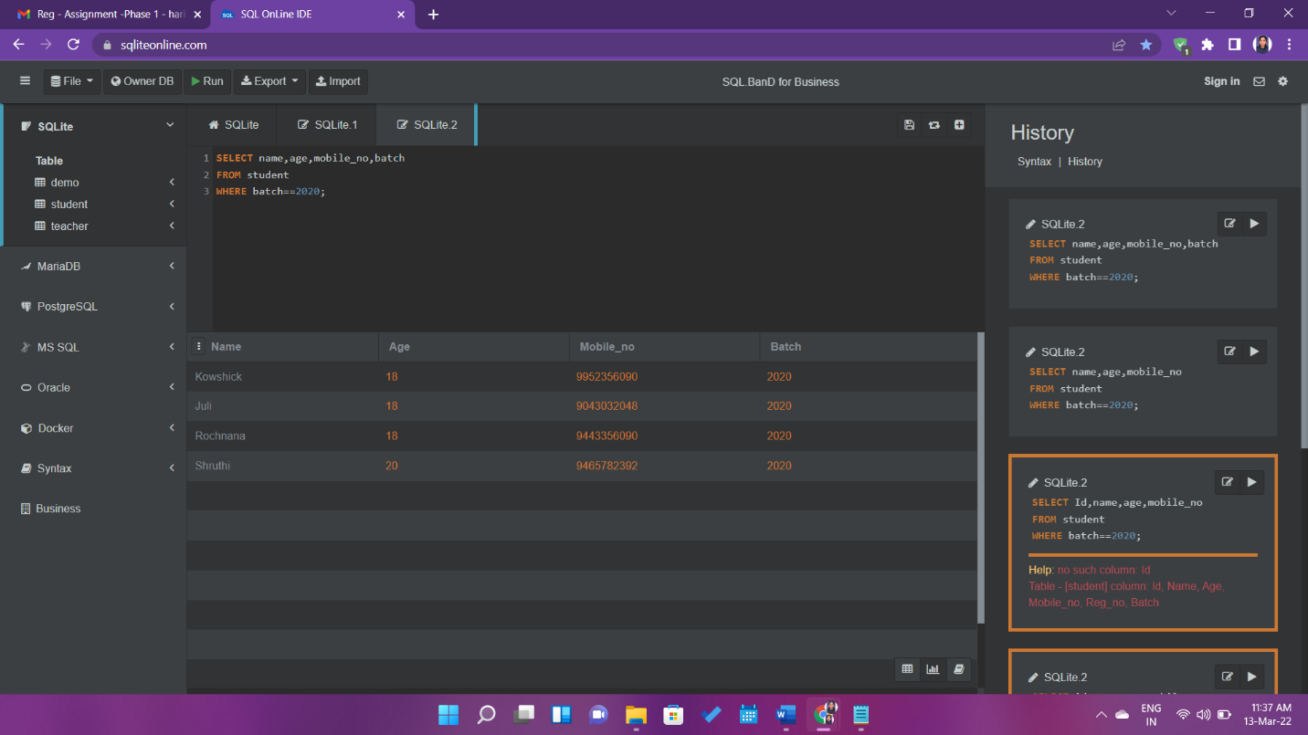

**QUERY**

SELECT name,age,mobile_no,batch

FROM student

WHERE batch==2020;

5.   Write a query to fetch all teachers from CS department

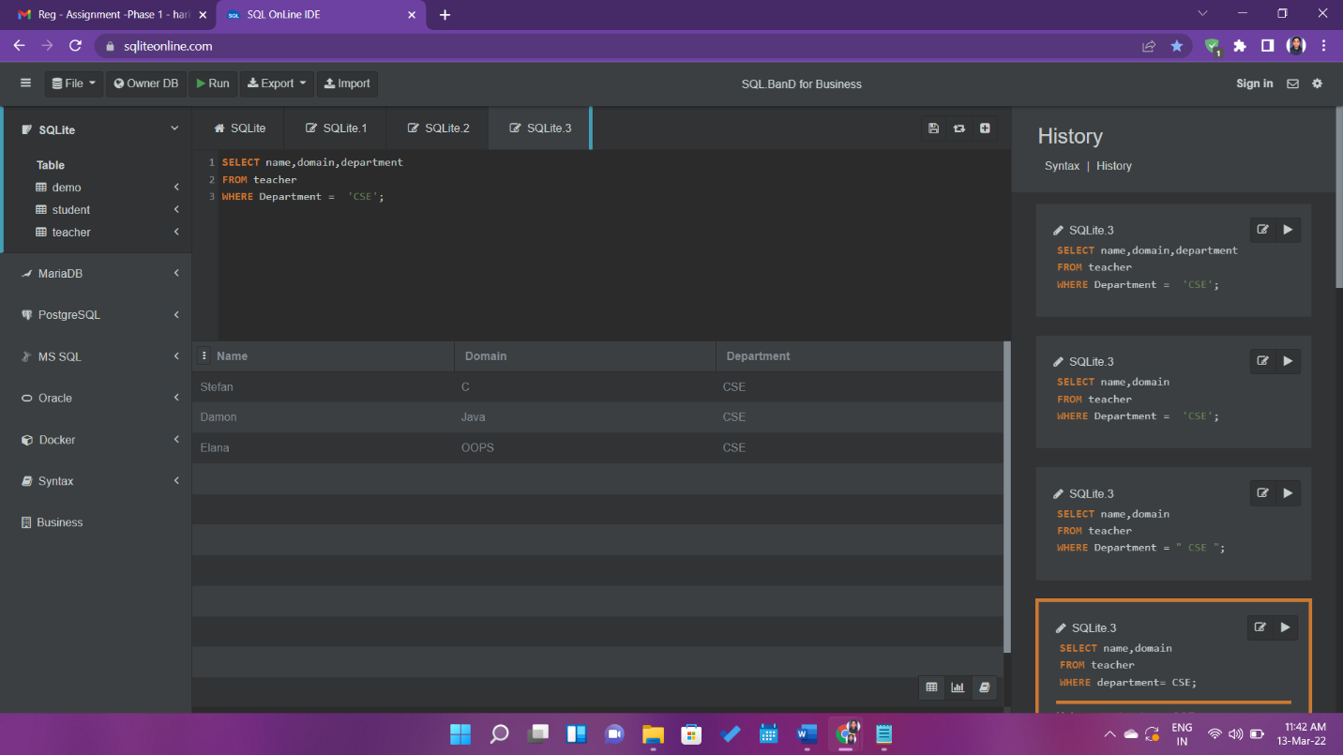

**QUERY**

SELECT name,domain,department

FROM teacher

WHERE Department = 'CSE';

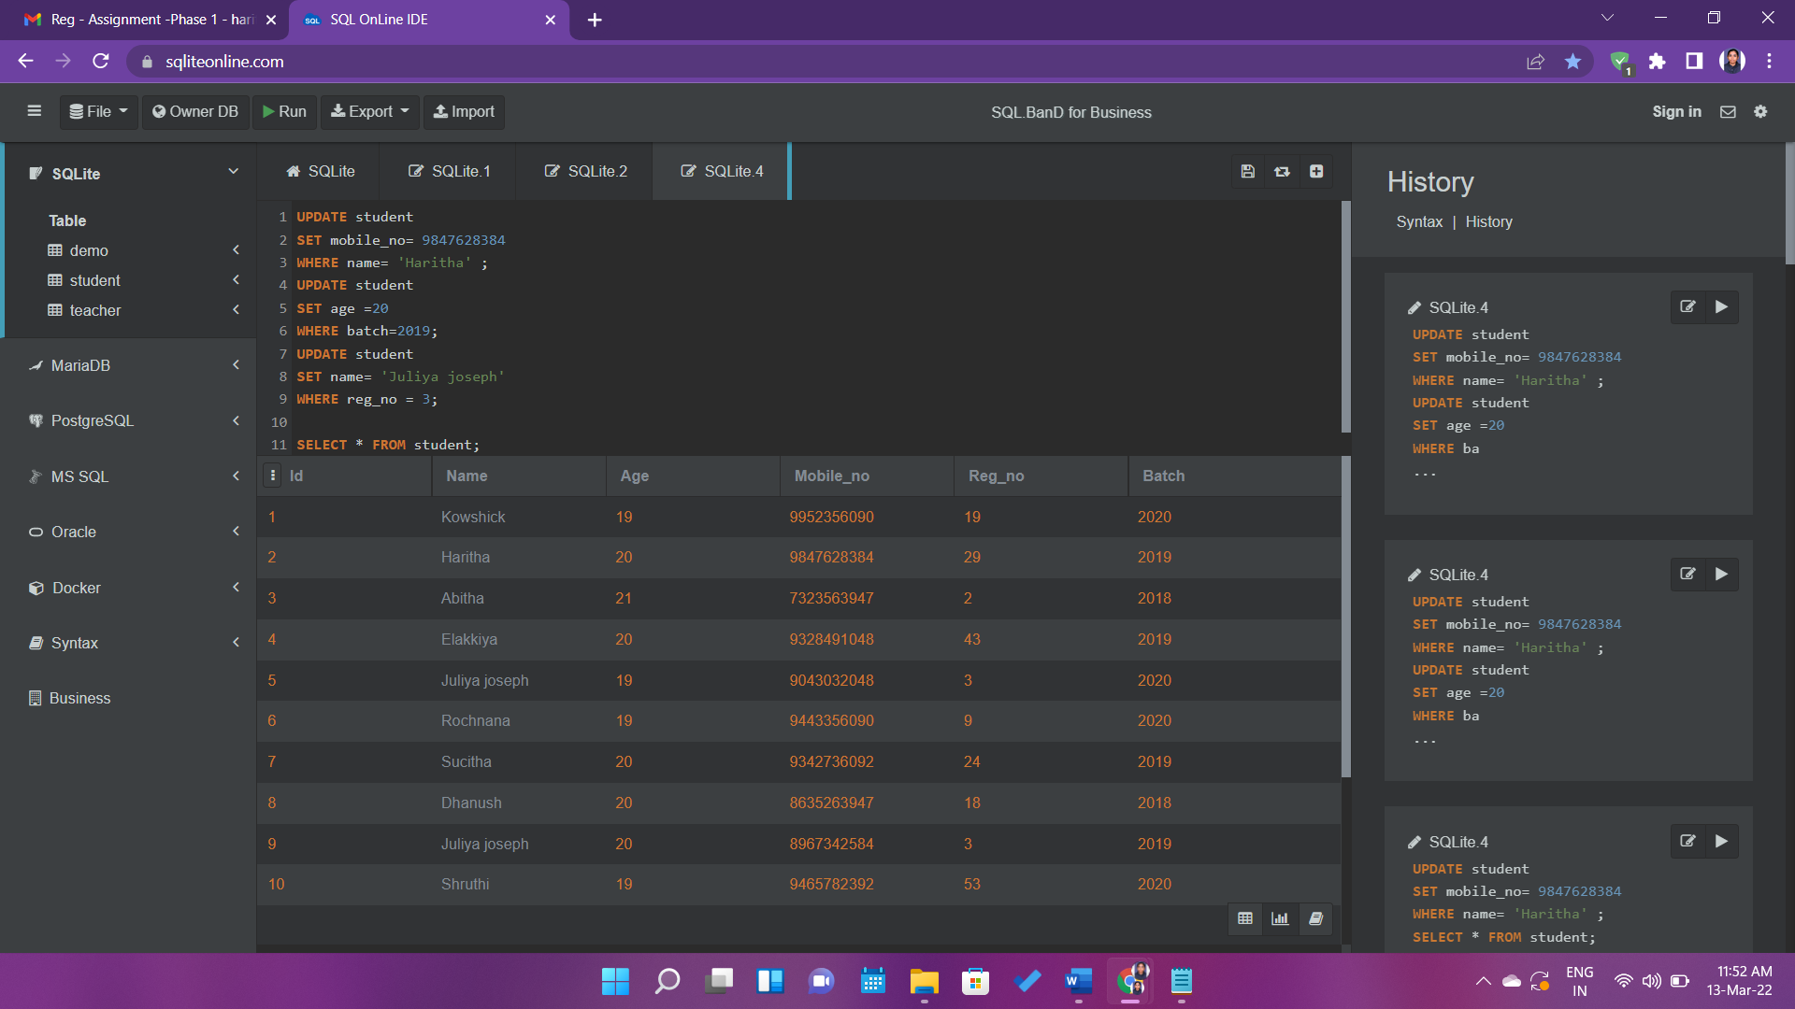6. Write a query to edit at least 3 records of students

**QUERY**

UPDATE student

SET mobile_no= 9847628384

WHERE name= 'Haritha' ;

UPDATE student

SET age =20

WHERE batch=2019;

UPDATE student

SET name= 'Juliya joseph'

WHERE reg_no = 3; SELECT * FROM student;

7.  Write a query to delete 2 records from teachers table.

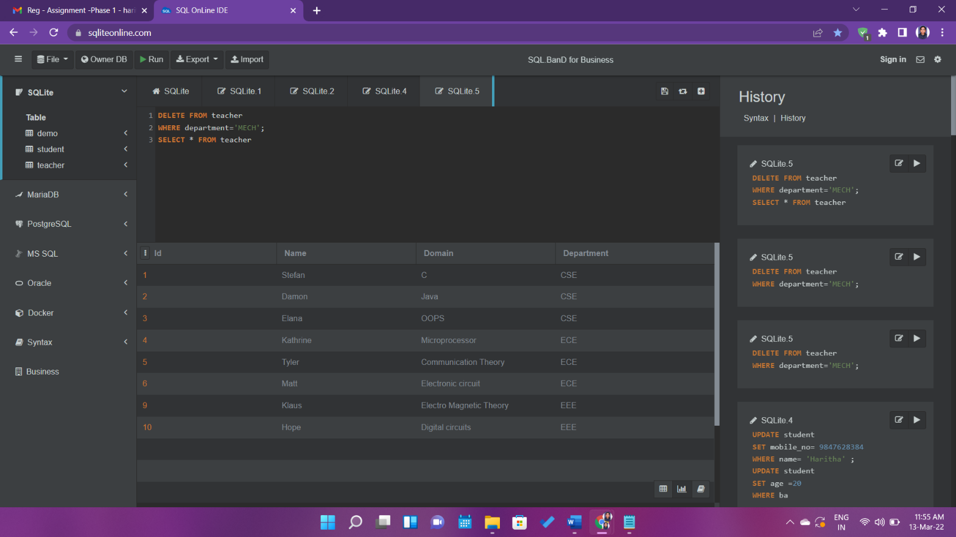

**QUERY**

DELETE FROM teacher

WHERE department='MECH';

SELECT * from teacher